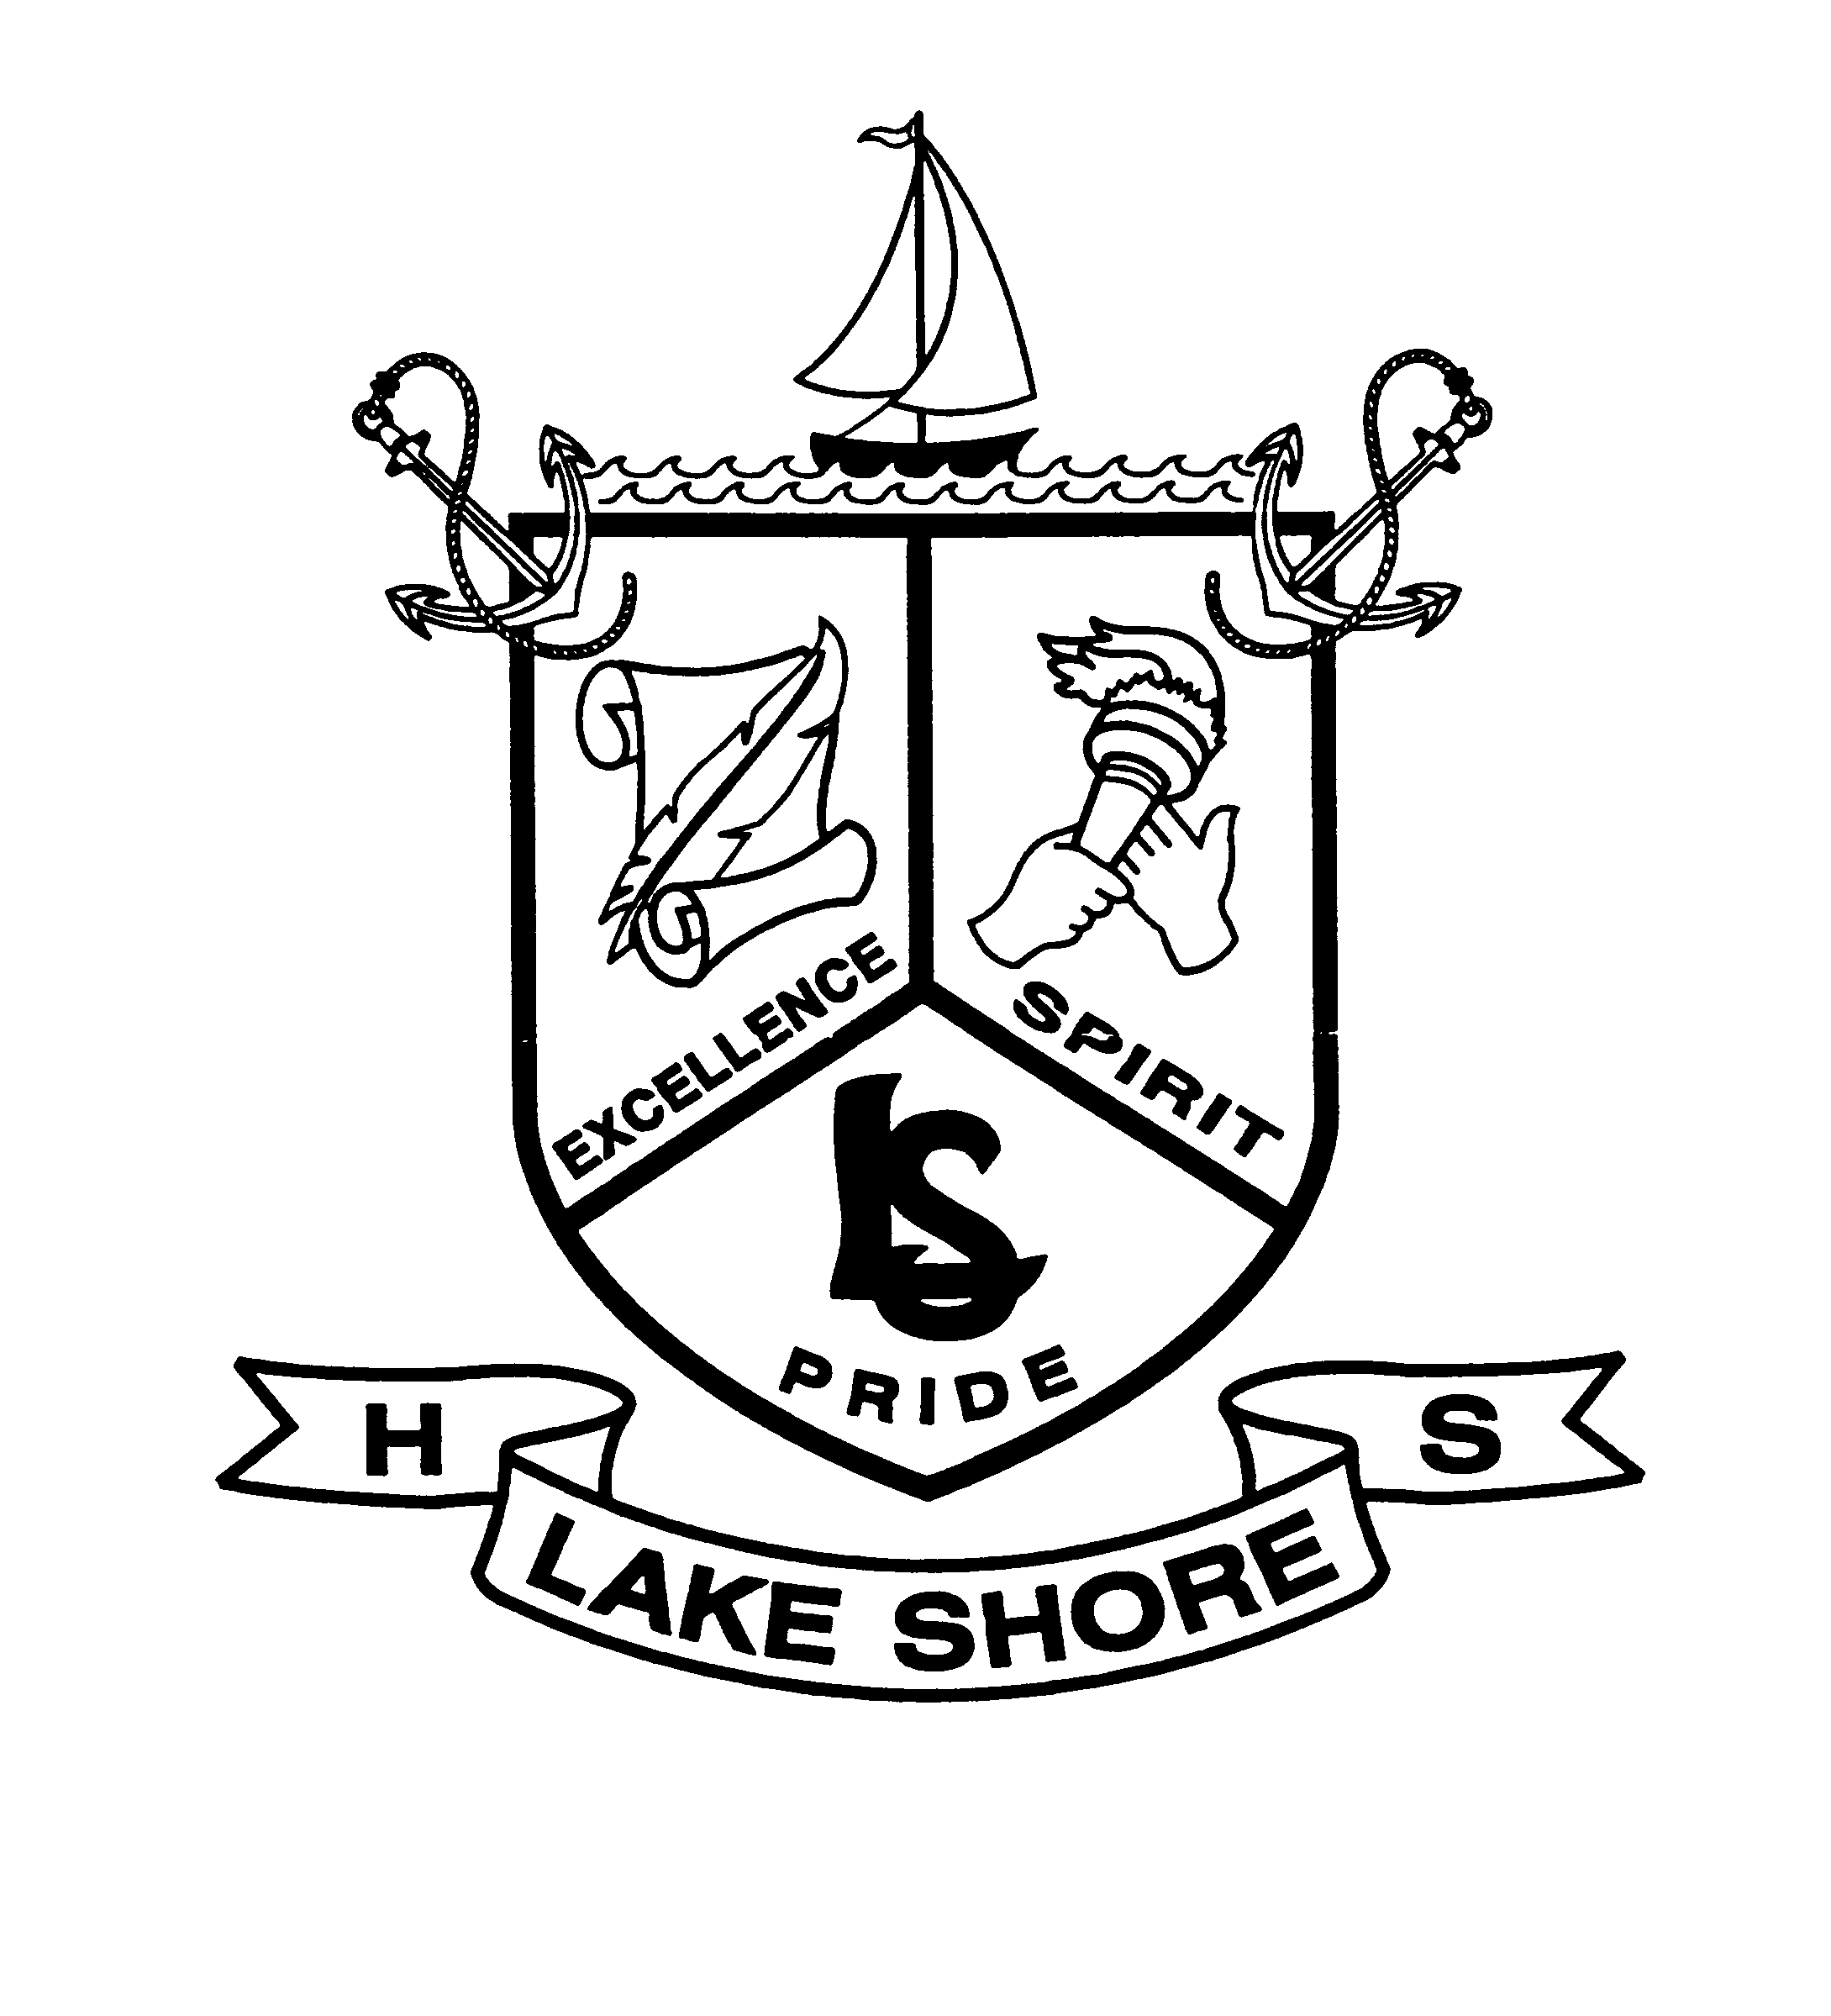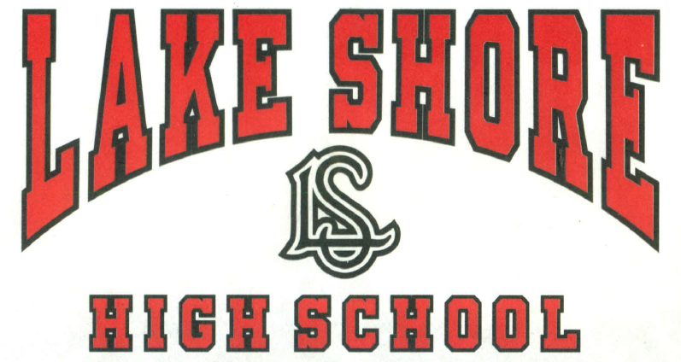

certifies that

**DAVID GILBOE**

has been recognized for working with his intern, Kennedy Vigliotti, at

**DAVID GILBOE & ASSOCIATES**

Insert STUDENT’S NAME here

