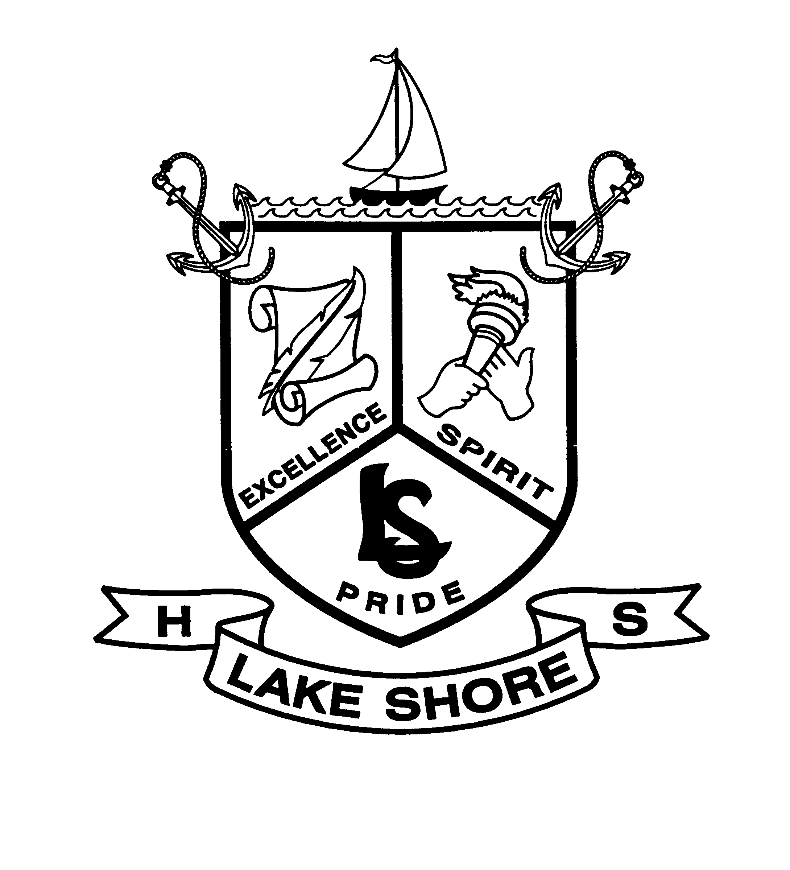

certifies that

**Kyree Jackson**

has successfully completed his internship experience at

**Oceans and Seas**

Insert STUDENT’S NAME here

