Have your cell phone win a FREE trip to the office just by using it in class.
Lucky winners can also get a phone call home to a parent or guardian for pick up on second offences!
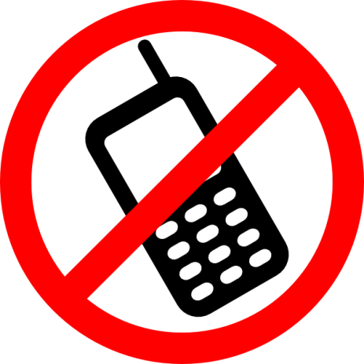
Your weekend will be full of excitement without your cell. /sarcasm
Won’t Mom and Dad be so proud?

