Kiwi | Orange
Grape | Banana

Carrot | Pea
Broccoli
Caption: I love veggies!

Skittle | 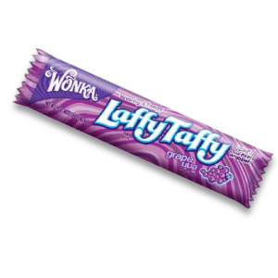
Taffy

Directions: EVERYONE must complete #1. Then, complete #2 OR #3. Your choice!
Finished? Show Mrs. Candela.

